Back

Sampling distributions

Quiz, 10 questions

Question 1

1  
point

**1. Question 1**

What is the difference between descriptive and inferential statistics?



Where inferential statistics only concerns the sample, descriptive statistics concerns the underlying population.



Where descriptive statistics only concerns the sample, inferential statistics concerns the underlying population.



Where inferential statistics is used with discrete variables, descriptive statistics is used with continous variables.



Where descriptive statistics is used with discrete variables, inferential statistics is used with continous variables.

Question 2

1  
point

**2. Question 2**

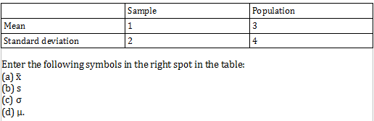



1(a), 2(b), 3(c), 4(d)



1(d), 2(c), 3(a), 4(b)



1(b), 2(c), 3(a), 4(d)



1(a), 2(b), 3(d), 4(c)

Question 3

1  
point

**3. Question 3**

Which of the statement(s) is/are correct?

I. A disadvantage of a telephone interview compared to a face-to-face questionnaire is that people tend to be less patient.

II. The cheapest way of collecting data is an online survey.



Statement I is correct, statement II is incorrect.



Statement II is correct, statement I is incorrect.



Both statements are incorrect.



Both statements are correct.

Question 4

1  
point

**4. Question 4**

How do you call the bias that can occur when not everybody from the population is included in the sampling frame?



Undercoverage



Sampling bias



Respons bias



Convenience sampling

1  
point

**5. Question 5**

Imagine you want to know the length of the beard of every male student in America. You know that the population mean equals 2.2 millimeters and the population standard deviation equals 0.9 millimeters. What will be the mean (in millimeters) of the sampling distribution of the sample mean (i.e., if you take an infinite number of samples)?

(1 decimal; use dot separator)



Question 6

1  
point

**6. Question 6**

What is the central limit theorem?



The central limit theorem says that the mean is centered if the sample size approximates infinity.



The central limit theorem says that the population distribution approximates a bell shape given that the sample is large enough.



The central limit theorem says that the sampling distribution approximates a bell shape given that the sample is large enough.



The central limit theorem says that the sampling distribution approximates a bell shape given that the sample is large enough and the population distribution is bell shaped.

Question 7

1  
point

**7. Question 7**

Which of the following statement(s) is/are true?



The sampling distribution of the sample mean is the distribution of an infinite number of sample means (with a given sample size).



The larger the variability in the population distribution, the larger the variability in the sampling distribution of the sample mean.



The standard deviation of the sampling distribution of the sample mean **is not**affected by the sample size.



The larger the sample, the more the standard deviation of the sampling distribution of the sample mean resembles the standard deviation in the population.

Question 8

1  
point

**8. Question 8**

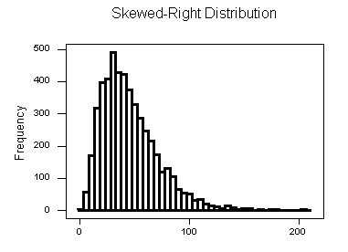

You know that the sample size is larger than 30.



This could be a population distribution or a data distribution.



This could be a population distribution, a data distribution or a sampling distribution.



This is a population distribution.



This is a sampling distribution.

1  
point

**9. Question 9**

You know that twenty percent of the people in Amsterdam describe themselves as Hipsters. You ask 400 respondents if they identify as a Hipster or not. What is the standard deviation of the sampling distribution of the sample proportion?

(2 decimals; use dot separator)



Question 10

1  
point

**10. Question 10**

Which conclusion can you draw if a data distribution is very different from the corresponding population distribution (provided that the sample size is very large)?



The population is biased.



The sample is biased and does not represent the population well.



You cannot conclude anything at this point. You have to do further research.



This is not a problem. Just continue the analysis.

Upgrade to submit